|  |  |  |  |  |
| --- | --- | --- | --- | --- |
| **National University of Computer and Emerging Sciences, Lahore Campus** | | | | |
| C:\Users\saif\AppData\Local\Microsoft\Windows\Temporary Internet Files\Content.Word\final design.jpg | **Course:** | **Software Design &Analysis** | **Course Code:** | **CS3004** |
| **Program:** | **BS (CS)** | **Semester:** | **Fall 2022** |
| **Duration:** | **180 Minutes (3 Hours)** | **Total Marks:** | **50** |
| **Paper Date:** | **19-Dec-22** | **Weight** | **40%** |
| **Section:** | **All** | **Page(s):** | **6** |
| **Exam:** | **Final** |  |  |
| **Instruction/Notes:** | Attempt all questions on the question paper. Neither use nor submit any extra sheet. | | | |

Name: _______________________________ Roll Number: ______________ Section _____

**Question 1**(Max. Marks =10) [CLO 3]

A curator manages a single museum. Every museum has an address, contact number, and opening date. There are only two types of museums i.e. art museums and science museums. Art museums house one or more art galleries whereas science museums house one or more science exhibits. Art galleries display multiple works of art. An art work can be either a painting or a sculpture. All art works have a unique identification number (UIN), artist name, price, and creation date. Paintings have a medium (i.e. oil, watercolor, pastel) and type (i.e. abstract, landscape, still life, contemporary) whereas sculptures have form (i.e. free standing, relief), method (i.e. carving, casting, modeling, assembling), and material (e.g. metal, wood, plastic, mud, cloth, etc.). Science exhibits display multiple science projects. A science project can be either a mechanical project or an electromechanical project. All science projects are developed by teams of 3 to 5 scientists. A scientist can belong to one or more teams. Each scientist has a name, date of birth, and Pakistan Engineering Council (PEC) registration number and each team has a name and license number. All science projects have a title and description. Mechanical projects have horsepower while electromechanical projects have voltage and frequency. In order to visit a museum, a visitor must purchase a ticket sold by that museum. Each visitor has a name, type (i.e. adult, child, student, senior citizen), and CNIC number while each ticket has a serial number, price, and expiry date. Students and senior citizens get 50% discount on the price of the ticket while children get 75% discount.

Model the information given above using a **design class diagram**. Your class diagram should not contain the operations (i.e. third) compartment of classes.

Use the **next page** for answering this question.

Name: _______________________________ Roll Number: ______________ Section _____

[Use this page for answering Question 1 only.]

Name: _______________________________ Roll Number: ______________ Section _____

**Question 2**(Max. Marks = 10) [CLO 3]

To approvethe design for a company’s new product,coordination is required amongst thedifferent departments of the company. The marketing department first generates a raw idea which is then sent to the engineering department. The engineering department simulates the function of the product and then prepares a design. This design is then checked for durability by the testing department. At the same time, the customer service department checksthe usability of the design. Once both of these departments have checked the design, the engineering department examines the results. If the results are satisfactory, the engineering department approves the design. Otherwise, the engineering departmentgoes back to prepare a new design. The same steps are repeated until the design is finally approved.

Construct a **swimlane activity diagram** below for the product design approval process described above.

Name: _______________________________ Roll Number: ______________ Section _____

**Question 3**(Max. Marks = 10) [CLO 3]

*Notifies*

**Subject**

***Observer***

…

*

1

+ *update(): void*

…

+ notify(): void

**Shop**

**Customer**

- myShop : Shop*

- myDiscount :int

*

1

+ update(): void

- discount :int

+ setDiscount(d: int): void

+ getDiscount(): int

Consider the design class diagram given above. It uses the Observer design pattern. When a shop object receives a setDiscount()message, it calls the notify() function which, in turn, sends the update() message to all registered customers. The customer objects then synchronize their state (myDiscount) with the state of the shop object (discount).

Draw a **design sequence diagram** below to show all messages passed between relevant objects when a shop object receives the setDiscount() message. Assume 2 customers are registered.

Name: _______________________________ Roll Number: ______________ Section _____

**Question 4**(Max. Marks = 10 = 1 x 10) [CLO 5]

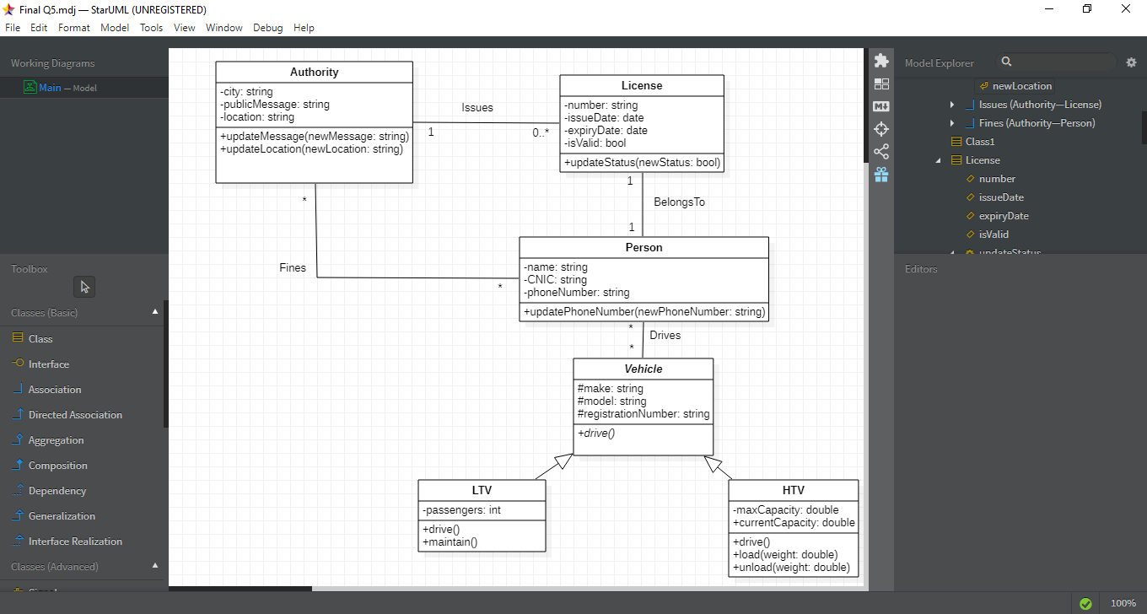

Without making any assumptions, use the information provided in the design class diagram above to determine the values of the OO metrics for the classes specified in the table below.

|  |  |  |  |
| --- | --- | --- | --- |
| **S#** | **Class** | **Metric** | **Value** |
| 1 | Authority | Weighted Methods per Class (WMC) |  |
| 2 | License | Weighted Methods per Class (WMC) |  |
| 3 | HTV | Weighted Methods per Class (WMC) |  |
| 4 | Vehicle | Depth of Inheritance Tree (DIT) |  |
| 5 | LTV | Depth of Inheritance Tree (DIT) |  |
| 6 | HTV | Depth of Inheritance Tree (DIT) |  |
| 7 | Vehicle | Number of Children (NOC) |  |
| 8 | LTV | Number of Children (NOC) |  |
| 9 | Person | Coupling Between Objects (CBO) |  |
| 10 | Vehicle | Coupling Between Objects (CBO) |  |

Name: _______________________________ Roll Number: ______________ Section _____

**Question 5**(Max. Marks = 10) [CLO 5]

Consider the following code:

struct Pair {

Student* x;

Student* y;

}

void foo() {

Pair pr1 = Student::getPair();

}

void bar() {

Pair pr2 = Student::getPair();

}

When function foo() calls getPair(), it gets a pair object containing (pointers to) two objects of the Student class. Afterwards, when function bar() calls getPair() it gets a pair object containing (pointers to) the same two Student objectsagain!

Use the space given below to write C++ code for the Student class that satisfies the description given above.

Important Note: Use a relevant design pattern.